Date:_____________________
ATTENTION PROPERTY OWNER
Only the owner can change or correct a mailing address
Please fill out the form below and return to: Buffalo Water / Veolia NA
281 Exchange St
Buffalo NY 14204
OR
Fax: (716)847-0150

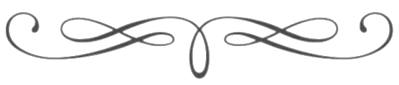

Account Number (REQUIRED) _____________________________

Address: ____________________________________________________________________________________________________________________________________

CHANGE MAILING ADDRESS TO:

Name: _____________________________________________________________

Address: ___________________________________________________________

City/State:__________________________________________________________

Zip Code:_____________________________

Phone #:______________________________

